
THE LICENSING ACT 2003

PREMISES LICENCE SUMMARY (PART B)

Premises licence number | HART/PS/540

Premises details

Postal address of premises or, if none, ordnance survey map reference, or description

Wallis & Co
Unit 12a – 15 Navigation Point

Post Town Hartlepool | Post code TS24 0UH

Telephone number 01429 862228

Where the licence is time limited the dates

N/A

Licensable activities authorised by the licence

Alcohol Sales – (On Sale)
Live Music

Recorded Music

The times the licence authorises the carrying out of licensable activities

Monday - Sunday 09:00 – 23:40

The opening hours of the premises

Monday - Sunday 09:00 – 00:00

Where the licence authorises supplies of alcohol whether these are on and / or off supplies

On Sales

Name, (registered) address of holder of premises licence

Mr Jonathan William Wallis
18 Leamington Parade
Hartlepool
TS25 5AF

Registered number of holder, for example company number, charity number (where applicable)

N/A

Name of designated premises supervisor where the premises licence authorises for the supply of alcohol
Mr Jonathan William Wallis

State whether access to the premises by children is restricted or prohibited

Restricted

Date licence granted: 1st January 2022

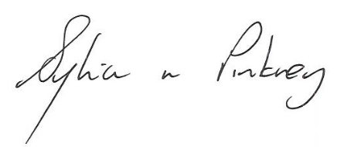

Sylvia Pinkney
Assistant Director
(Regulatory Services)

The Licensing Section
Public Protection Division
Hartlepool Borough Council
Civic Centre
Victoria Road
Hartlepool
TS24 8AY

