THE LICENSING ACT 2003

PREMISES LICENCE SUMMARY (PART B)

Premises licence number | HART/PS/303

Premises details
Postal address of premises or, if none, ordnance survey map reference, or description
Sheesh Mahal
27/28 Navigation Point
Hartlepool Marina

Post Town Hartlepool | Post Code TS24 0UJ

Telephone number 01429 860818

Where the licence is time limited the dates

N/A

Licensable activities authorised by the licence. Any entertainment authorised by this licence is limited to indoors only, unless stated otherwise.

- Supply of Alcohol (On & Off Licence)
- Live Music
- Recorded Music
- Performance of Dance
- Anything similar to 2, 3 or 4 above.
- Provision of Late Night Refreshment

The times the licence authorises the carrying out of licensable activities

- Supply of Alcohol (On & Off Licence)
- Live Music
- Recorded Music
- Performance of Dance
- Anything similar to 2, 3 or 4 above.
- Provision of Late Night Refreshment

Monday to Sunday 1100 –2400

The opening hours of the premises

Monday to Sunday 1100 – 2400

Where the licence authorises supplies of alcohol whether these are on and / or off supplies

On & Off Sales

Name, (registered) address of holder of premises licence

Mrs Syeda Shafna Begum
56 Sandringham Road
Hartlepool
TS26 8EY

Registered number of holder, for example company number, charity number (where applicable)

N/A

Name of designated premises supervisor where the premises licence authorises for the supply of alcohol

Mrs Syeda Shafna Begum

State whether access to the premises by children is restricted or prohibited

Restricted

Date Licence Granted: 26th April 2017

Director of Public Health

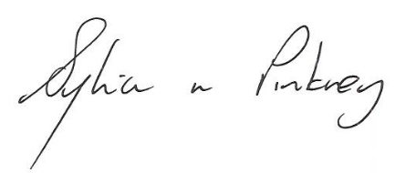

Sylvia Pinkney
Assistant Director
(Regulatory Services)

The Licensing Section
Public Protection Division
Hartlepool Borough Council
Civic Centre
Victoria Road
Hartlepool
TS24 8AY

