

THE LICENSING ACT 2003

PREMISES LICENCE SUMMARY (PART B)

Premises licence number | HART/PS/515

Premises details
Postal address of premises or, if none, ordnance survey map reference, or description
32 Navigation Point

Post Town Hartlepool | Post Code TS24 0UJ

Telephone number 07932511214

Where the licence is time limited the dates

N/A

Licensable activities authorised by the licence. Any entertainment authorised by this licence is limited to indoors only, unless stated otherwise.

1. Supply of Alcohol
2. Live Music
3. Recorded Music

This licence does not authorise the provision of adult entertainment.

The times the licence authorises the carrying out of licensable activities

1. Supply of Alcohol Monday – Sunday 10:00 – 23:00

The opening hours of the premises

Monday – Sunday 08:00 – 23:00

Where the licence authorises supplies of alcohol whether these are on and / or off supplies

On and Off Sales

Name, (registered) address of holder of premises licence

Grace (Hartlepool) Ltd
9 Hopps Street
Hartlepool
TS26 8RA

Registered number of holder, for example company number, charity number (where applicable)

11279275

Name of designated premises supervisor where the premises licence authorises for the supply of alcohol

Anastasia Elizabeth Grace Mellen

State whether access to the premises by children is restricted or prohibited

Restricted

Date Licence Granted: 1st March 2019

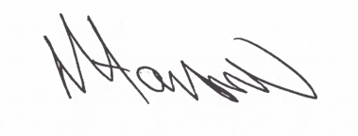
Assistant Director
(Environment & Neighbourhood Services)

The Licensing Section
Hartlepool Borough Council
Civic Centre
Victoria Road
Hartlepool
TS24 8AY

