

THE LICENSING ACT 2003

PREMISES LICENCE SUMMARY (PART B)

Premises licence number | HART/PS/520

Premises details
Postal address of premises or, if none, ordnance survey map reference, or description

Unit 30 Navigation Point
Middleton Road

Post Town Hartlepool | Post Code TS24 0UH

Telephone number 07919996045

Where the licence is time limited the dates

N/A

Licensable activities authorised by the licence. Any entertainment authorised by this licence is limited to indoors only, unless stated otherwise.

Alcohol Sales (On & Off Sales)
Live Music
Recorded Music

This licence does not authorise the provision of adult entertainment.

The times the licence authorises the carrying out of licensable activities

Alcohol Sales Monday – Saturday 09:00 – 23:30
Sunday 09:00 – 22:30
New Years Eve until 01:00

Live Music Thursday & Friday 14:00 – 21:00
New Years Eve until 24:00

Recorded Music Monday – Saturday 09:00 – 23:30
Sunday 09:00 – 22:30

The opening hours of the premises

Monday – Saturday 09:00 – 00:00
Sunday 09:00 – 23:00
New Years Eve until 01:00

Where the licence authorises supplies of alcohol whether these are on and / or off supplies

On & Off Sales

Name, (registered) address of holder of premises licence

Mr Joshua Mark Murphy
243a Oxford Road
Hartlepool
TS25 5QD

Registered number of holder, for example company number, charity number (where applicable)

N/A

Name of designated premises supervisor where the premises licence authorises for the supply of alcohol

Mr Joshua Mark Murphy

State whether access to the premises by children is restricted or prohibited

Unrestricted

Date Licence Granted: 11th May 2022

Licence Authorised by: 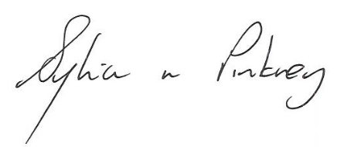

Sylvia Pinkney, Assistant Director
(Regulatory Services)

The Licensing Section
Hartlepool Borough Council
Civic Centre
Victoria Road
Hartlepool
TS24 8AY

