

THE LICENSING ACT 2003

PREMISES LICENCE SUMMARY (PART B)

Premises licence number | HART/489

Premises details
Postal address of premises or, if none, ordnance survey map reference, or description
130 Northgate

Post Town Hartlepool | Post Code TS24 0EJ

Telephone number 07532331726

Where the licence is time limited the dates

N/A

Licensable activities authorised by the licence. Any entertainment authorised by this licence is limited to indoors only, unless stated otherwise.

Provision of Late Night Refreshment

This licence does not authorise the provision of adult entertainment.

The times the licence authorises the carrying out of licensable activities

Friday, Saturday and Sundays 23:00 – 23:30

The opening hours of the premises

Monday to Thursday 16:00 – 23:00
Friday, Saturday and Sundays 16:00 – 23:30

Where the licence authorises supplies of alcohol whether these are on and / or off supplies

N.A.

Name, (registered) address of holder of premises licence

Mr Jamil Ahmed
130 Northgate
Hartlepool
TS24 0EJ

Tel: 07532331726

Registered number of holder, for example company number, charity number (where applicable)

N/A

Name of designated premises supervisor where the premises licence authorises for the supply of alcohol

N/A

State whether access to the premises by children is restricted or prohibited

Unrestricted

Date Licence Granted: 26th August 2015

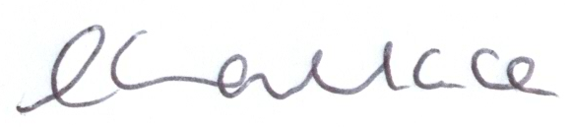
Director of Public Health

The Licensing Section
Hartlepool Borough Council
Civic Centre
Victoria Road
Hartlepool
TS24 8AY

