THE LICENSING ACT 2003

PREMISES LICENCE SUMMARY (PART B)

Premises licence number | HART/PS/217

Premises details
Postal address of premises or, if none, ordnance survey map reference, or description

Bambinos
56 Owton Manor Lane

Post Town Hartlepool | Post Code TS25 3AU

Telephone number 01429 272731

Where the licence is time limited the dates

N/A

Licensable activities authorised by the licence. Any entertainment authorised by this licence is limited to indoors only, unless stated otherwise.

Late Night Refreshment

The times the licence authorises the carrying out of licensable activities

Late Night Refreshment
Monday to Saturday 23:00 – 23:30

The opening hours of the premises

At the discretion of the licence holder

Where the licence authorises supplies of alcohol whether these are on and / or off supplies

N/A

Name, (registered) address of holder of premises licence

Zafar Suleman
103 Hall Drive
Acklam
Middlesbrough
TS5 7HX

Registered number of holder, for example company number, charity number (where applicable)

Name of designated premises supervisor where the premises licence authorises for the supply of alcohol

State whether access to the premises by children is restricted or prohibited

Unrestricted

Date Licence Granted: 6th February 2018

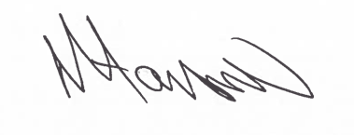

Assistant Director
(Environment & Neighbourhood Services)

The Licensing Section
Public Protection and Housing
Hartlepool Borough Council
Civic Centre
Victoria Road
Hartlepool
TS24 8AY

