THE LICENSING ACT 2003

PREMISES LICENCE SUMMARY (PART B)

Premises licence number | HART/PS/211

Premises details

Postal address of premises or, if none, ordnance survey map reference, or description

202 – 206 Owton Manor Lane

Post Town Hartlepool | Post code TS25 0LB

Telephone number 01429 275037

Where the licence is time limited the dates

N/A

Licensable activities authorised by the licence

Alcohol Sales

Off-Licence

The times the licence authorises the carrying out of licensable activities

Alcohol Sales

Off-Licence Monday – Saturday 0800 – 2300
Sunday 1000 – 2230
Christmas Day 1200 – 1500
1900 – 2230
Good Friday 0800 – 2230

The opening hours of the premises

At the discretion of the licensee

Where the licence authorises supplies of alcohol whether these are on and / or off supplies

Off-sales

Name, (registered) address of holder of premises licence

Meehu Ltd
44 Station Road
Redcar
TS10 1AG

Registered number of holder, for example company number, charity number (where applicable)

09008783

Name of designated premises supervisor where the premises licence authorises for the supply of alcohol
Ravi Gopal

State whether access to the premises by children is restricted or prohibited

Unrestricted

Date licence granted: 27th September 2021

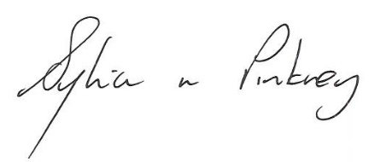
Sylvia Pinkney
Assistant Director
(Regulatory Services)

The Licensing Section
Public Protection Division
Hartlepool Borough Council
Civic Centre
Victoria Road
Hartlepool
TS24 8AY

