THE LICENSING ACT 2003

PREMISES LICENCE SUMMARY (PART B)

Premises licence number | HART/PS/367

Premises details
Postal address of premises or, if none, ordnance survey map reference, or description

One Stop Stores
220 – 220a Owton Manor Lane

Post Town Hartlepool | Post Code TS25 3QD

Telephone number 01429 860069

Where the licence is time limited the dates

N/A

Licensable activities authorised by the licence. Any entertainment authorised by this licence is limited to indoors only, unless stated otherwise.

Supply of Alcohol

The times the licence authorises the carrying out of licensable activities

Monday to Sunday 06:00 – 23:00

The opening hours of the premises

Monday to Sunday 06:00 – 23:00

Where the licence authorises supplies of alcohol whether these are on and / or off supplies

Off Supplies Only

Name, (registered) address of holder of premises licence

One Stop Stores Limited
Apex Road
Brownhills
Walsall
West Midlands
WS8 7TS

Registered number of holder, for example company number, charity number (where applicable)

02462858

Name of designated premises supervisor where the premises licence authorises for the supply of alcohol

Martin Andrew Gallimore

State whether access to the premises by children is restricted or prohibited

Unrestricted

Date Licence Granted: 8th January 2019

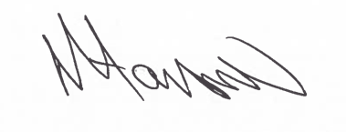
Assistant Director
(Environment & Neighbourhood Services)

The Licensing Section
Hartlepool Borough Council
Civic Centre
Victoria Road
Hartlepool
TS24 8AY

