

THE LICENSING ACT 2003

PREMISES LICENCE SUMMARY (PART B)

Premises licence number | HART/PS/555

Premises details
Postal address of premises or, if none, ordnance survey map reference, or description
141 Oxford Road

Post Town Hartlepool | Post Code

Telephone number 07472418006

Where the licence is time limited the dates

N/A

Licensable activities authorised by the licence. Any entertainment authorised by this licence is limited to indoors only, unless stated otherwise.

Supply of Alcohol

This licence does not authorise the provision of adult entertainment.

The times the licence authorises the carrying out of licensable activities

09:00 – 22:00 Monday - Sunday

The opening hours of the premises

06:00 – 22:00 Monday - Sunday

Where the licence authorises supplies of alcohol whether these are on and / or off supplies

Off Sales Only

Name, (registered) address of holder of premises licence

Sultan Mahmood Goher
141A Oxford Road
Hartlepool
TS25 5RJ

Registered number of holder, for example company number, charity number (where applicable)

N/A

Name of designated premises supervisor where the premises licence authorises for the supply of alcohol

Sultan Mahmood Goher

State whether access to the premises by children is restricted or prohibited

Unrestricted

Date Licence Granted: 13th February 2020

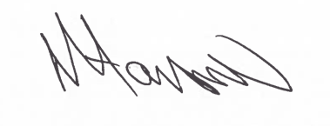
Tony Hanson
Assistant Director
(Environment & Neighbourhood Services)

The Licensing Section
Hartlepool Borough Council
Civic Centre
Victoria Road
Hartlepool
TS24 8AY

