

THE LICENSING ACT 2003

PREMISES LICENCE SUMMARY (PART B)

Premises licence number | HART/PS/470

Premises details
Postal address of premises or, if none, ordnance survey map reference, or description
Sams Snooker & American Pool
76-86 Park Road

Post Town Hartlepool | Post Code TS26 9HU

Telephone number 01429 278347

Where the licence is time limited the dates
N/A

Licensable activities authorised by the licence. Any entertainment authorised by this licence is limited to indoors only, unless stated otherwise.

1. Supply of Alcohol
2. Indoor Sporting Events
3. Recorded Events

This licence does not authorise the provision of adult entertainment.

The times the licence authorises the carrying out of licensable activities

1. | Supply of Alcohol | Mon – Sat 09:00 – 23:00 Sun 09:00 – 22:30:
2. | Indoor Sporting Events | Mon – Sat 09:00 – 23:00 Sun 09:00 – 22:30
3. | Recorded Music | Mon - Sat 09:00 – 23:00 Sun 09:00 – 22:30

The opening hours of the premises

Mon – Sat 09:00 – 23:00
Sunday 09:00 – 22:30

Where the licence authorises supplies of alcohol whether these are on and / or off supplies

On & Off Sales

Name, (registered) address of holder of premises licence

Mrs Tracy Christine McAllister
7 Holdforth Road
Hartlepool
TS24 9AL

Tel: 01429 867629 Mobile: 07903741326
Email: tracy.macallister2@gmail.com

Registered number of holder, for example company number, charity number (where applicable)

N/A

Name of designated premises supervisor where the premises licence authorises for the supply of alcohol

Mrs Tracy Christine McAllister

State whether access to the premises by children is restricted or prohibited

Restricted

Date Licence Granted: 27th September 2014

Signed: 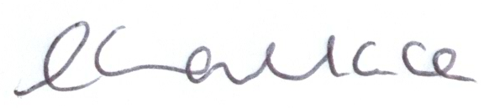

Director of Public Health

The Licensing Section
Hartlepool Borough Council
Civic Centre
Victoria Road
Hartlepool
TS24 8AY

