

THE LICENSING ACT 2003

PREMISES LICENCE SUMMARY (PART B)

Premises licence number | HART/539

Premises details
Postal address of premises or, if none, ordnance survey map reference, or description
103 Park Road

Post Town Hartlepool | Post Code TS26 9HP

Telephone number 01429 221115

Where the licence is time limited the dates

Licensable activities authorised by the licence. Any entertainment authorised by this licence is limited to indoors only, unless stated otherwise.

Supply of Alcohol

This licence does not authorise the provision of adult entertainment.

The times the licence authorises the carrying out of licensable activities

Supply of Alcohol
Mon – Sat 12:00 - 1600
Sun 10:00 – 16:00
The above times may be extended from 16:00 to 22:00 hours on two occasions per calendar month

The opening hours of the premises

Mon – Sat 08:00 – 23:00
Sun 09:00 – 22:00

Where the licence authorises supplies of alcohol whether these are on and / or off supplies

On Sales

Name, (registered) address of holder of premises licence

Andrew Bood
19 Amberwood Close
Hartlepool
TS27 3QL

Registered number of holder, for example company number, charity number (where applicable)

N/A

Name of designated premises supervisor where the premises licence authorises for the supply of alcohol

Andrew Bood

State whether access to the premises by children is restricted or prohibited

Unrestricted

Date Licence Granted: 22nd October 2018

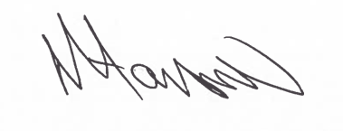
Assistant Director
(Environment & Neighbourhood Services)

The Licensing Section
Hartlepool Borough Council
Civic Centre
Victoria Road
Hartlepool
TS24 8AY

