THE LICENSING ACT 2003

PREMISES LICENCE SUMMARY (PART B)

Premises licence number | HART/PS/102

Premises details
Postal address of premises or, if none, ordnance survey map reference, or description

2 Powlett Road

Post Town Hartlepool | Post Code TS24 8LZ

Telephone number 01429 273097

Where the licence is time limited the dates

N/A

Licensable activities authorised by the licence. Any entertainment authorised by this licence is limited to indoors only, unless stated otherwise.

Alcohol Sales (Off Licence)

The times the licence authorises the carrying out of licensable activities

Alcohol Sales (Off Licence)

Monday to Sunday 0600 - 2400

The opening hours of the premises

At the discretion of the licence holder

Where the licence authorises supplies of alcohol whether these are on and / or off supplies

Off Sales

Name, (registered) address of holder of premises licence

Mr Nagarasa Theiva
2 Powlett Road
Hartlepool
TS24 8LZ

Registered number of holder, for example company number, charity number (where applicable)

N/A

Name of designated premises supervisor where the premises licence authorises for the supply of alcohol

Mr Nagarasa Theiva

State whether access to the premises by children is restricted or prohibited

Unrestricted

Date Licence Granted: 7th October 2019

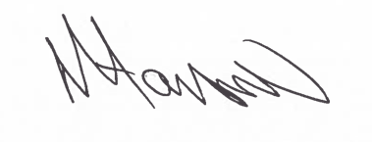
Tony Hanson
Assistant Director
(Environment & Neighbourhood Service)

The Licensing Section
Public Protection Division
Hartlepool Borough Council
Civic Centre
Victoria Road
Hartlepool
TS24 8AY

