

THE LICENSING ACT 2003

PREMISES LICENCE SUMMARY (PART B)

Premises licence number | HART/PS/428

Premises details
Postal address of premises or, if none, ordnance survey map reference, or description
SPAR Store
The Powlett
Powlett Road

Post Town Hartlepool | Post Code TS24 8NA

Telephone number 01429 269836

Where the licence is time limited the dates

N/A

Licensable activities authorised by the licence. Any entertainment authorised by this licence is limited to indoors only, unless stated otherwise.

Supply of Alcohol

This licence does not authorise the provision of adult entertainment.

The times the licence authorises the carrying out of licensable activities

Monday - Sunday 0700 -2300

The opening hours of the premises

Monday - Sunday 0700 -2300

Where the licence authorises supplies of alcohol whether these are on and / or off supplies

Off Supplies

Name, (registered) address of holder of premises licence

James Hall & Company Ltd
SPAR Distribution Centre
Bowland View
Preston
Lancashire
PR2 5QT

Tel:- 01772 706676 Email Kym.halton@jameshall.co.uk

Registered number of holder, for example company number, charity number (where applicable)

1022295

Name of designated premises supervisor where the premises licence authorises for the supply of alcohol

Tracy Jane Flanagan

State whether access to the premises by children is restricted or prohibited

Unrestricted

Date Licence Granted: 6th July 2021

Licence Authorised by:

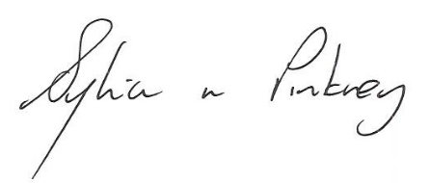

Sylvia Pinkney
Assistant Director (Regulatory Services)

The Licensing Section
Hartlepool Borough Council
Civic Centre
Victoria Road
Hartlepool
TS24 8AY

