

THE LICENSING ACT 2003

PREMISES LICENCE SUMMARY (PART B)

Premises licence number | HART/PS/466

Premises details
Postal address of premises or, if none, ordnance survey map reference, or description
The New Engineers Social Club
28 Raby Road

Post Town Hartlepool | Post Code TS24 8AE

Telephone number

Where the licence is time limited the dates
N/A

Licensable activities authorised by the licence. Any entertainment authorised by this licence is limited to indoors only, unless stated otherwise.

1. Supply of Alcohol
2. Indoor Sporting Event
3. Boxing or Wrestling
4. Live Music
5. Recorded Music
6. Performance of Dance
7. Anything similar to 4, 5 or 6 above

This licence does not authorise the provision of adult entertainment.

The times the licence authorises the carrying out of licensable activities

1. Supply of Alcohol | Monday – Sunday | 11:00 – 24:00
2. Indoor Sporting Events | Monday – Friday | 18:00 – 24:00
 | Saturday & Sunday | 11:00 – 24:00
3. Boxing or Wrestling | Monday – Sunday | 18:00 – 24:00
4. Live Music | Monday – Sunday | 11:00 – 24:00
5. Recorded Music | Monday – Sunday | 11:00 – 24:00
6. Performance of Dance | Monday – Sunday | 11:00 – 24:00
7. Anything similar | Monday – Sunday | 11:00 – 24:00

The opening hours of the premises

Monday to Sunday | 11:00 – 00:30

Where the licence authorises supplies of alcohol whether these are on and / or off supplies

On & Off Sales

Name, (registered) address of holder of premises licence

Mr Walter Cook & Mrs Elizabeth Cook
EMS Cottage
Whitehouse Farm
Whitton
Stockton on Tees
TS21 1LQ

Tel: 07976706492

Registered number of holder, for example company number, charity number (where applicable)

N/A

Name of designated premises supervisor where the premises licence authorises for the supply of alcohol

Mr Walter Cook

State whether access to the premises by children is restricted or prohibited

Restricted

Signed: 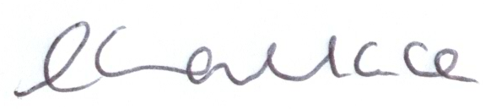

Director of Public Health

Date Licence Granted: 18th July 2014

The Licensing Section
Hartlepool Borough Council
Civic Centre
Victoria Road
Hartlepool
TS24 8AY

