

THE LICENSING ACT 2003

PREMISES LICENCE SUMMARY (PART B)

Premises licence number | HART/ PS/523

Premises details
Postal address of premises or, if none, ordnance survey map reference, or description
184 Raby Road

Post Town Hartlepool | Post Code TS24 8LF

Telephone number 01429 262121

Where the licence is time limited the dates

N/A

Licensable activities authorised by the licence. Any entertainment authorised by this licence is limited to indoors only, unless stated otherwise.

Late Night Refreshment

This licence does not authorise the provision of adult entertainment.

The times the licence authorises the carrying out of licensable activities

Late Night Refreshment
Monday – Sunday 23:00-Midnight

The opening hours of the premises

Monday – Sunday 16:00-Midnight

Where the licence authorises supplies of alcohol whether these are on and / or off supplies

N/A

Name, (registered) address of holder of premises licence

Mr Omed Mawlodi
53 Errol Street
Middleborough
TS1 3LW

Registered number of holder, for example company number, charity number (where applicable)

N/A

Name of designated premises supervisor where the premises licence authorises for the supply of alcohol

N/A

State whether access to the premises by children is restricted or prohibited

Unrestricted

Date Licence Granted: 27th February 2020

Licence Authorised by:

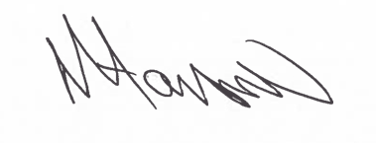
Tony Hanson
Assistant Director
(Environment & Neighbourhood Services)

The Licensing Section
Hartlepool Borough Council
Civic Centre
Victoria Road
Hartlepool
TS24 8AY

