THE LICENSING ACT 2003

PREMISES LICENCE SUMMARY (PART B)

Premises licence number | HART/PS/315

Premises details
Postal address of premises or, if none, ordnance survey map reference, or description

186 Raby Road

Post Town Hartlepool | Post Code TS24 8LF

Telephone number 01429 262947

Where the licence is time limited the dates
N/A

Licensable activities authorised by the licence. Any entertainment authorised by this licence is limited to indoors only, unless stated otherwise.

The provision of Late Night Refreshment

The times the licence authorises the carrying out of licensable activities

Late Night Refreshment:-

Monday – Sunday 23.00 – 24.00

The opening hours of the premises

Monday to Saturday 11.30 – 13.30 and 17.00 – 24.00
Sundays 17.00 – 24.00

Where the licence authorises supplies of alcohol whether these are on and / or off supplies

N/A

Name, (registered) address of holder of premises licence

Mr Shusheng Chen
186 Raby Road
Hartlepool
TS24 8LF

Registered number of holder, for example company number, charity number (where applicable)

N/A

Name of designated premises supervisor where the premises licence authorises for the supply of alcohol

N/A

State whether access to the premises by children is restricted or prohibited

Restricted

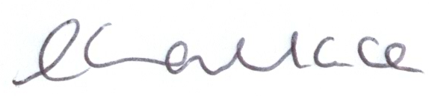

Licence Authorised By:

Louise Wallace
Director of Public Health

Date Licence Granted: 17th September 2013

The Licensing Section
Hartlepool Borough Council
Civic Centre
Victoria Road
Hartlepool
TS24 8AY

