THE LICENSING ACT 2003

PREMISES LICENCE SUMMARY (PART B)

Premises licence number | HART/PS/133

Premises details

Postal address of premises or, if none, ordnance survey map reference, or description

Abby Park Store
Rossmere Way

Post Town Hartlepool | Post code TS25 5EG

Telephone number 01429 597810

Where the licence is time limited the dates

N/A

Licensable activities authorised by the licence

Alcohol Sales

Off-Licence

The times the licence authorises the carrying out of licensable activities

Alcohol Sales

Off-Licence Monday – Saturday 0800 – 2300
Sunday 1000 – 2230
Christmas Day 1200 – 1500
1900 – 2230
Good Friday 0800 – 2230

The opening hours of the premises

At the discretion of the licensee

Where the licence authorises supplies of alcohol whether these are on and / or off supplies

Off-sales

Name, (registered) address of holder of premises licence

Mr Shanmugam Sandanarajah
Orchard End
Rossmere Way
Hartlepool
TS25 5EG

Registered number of holder, for example company number, charity number (where applicable)

N/A

Name of designated premises supervisor where the premises licence authorises for the supply of alcohol

Mrs Piramila Mathiyalkian

State whether access to the premises by children is restricted or prohibited

Unrestricted

Date licence granted: 17th January 2022

Licence Authorised by:

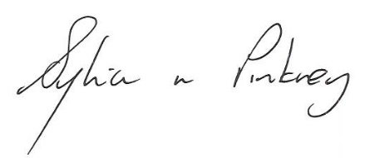

Sylvia Pinkney
Assistant Director
(Regulatory Services)

The Licensing Section
Public Protection Division
Hartlepool Borough Council
Civic Centre
Victoria Road
Hartlepool
TS24 8AY

