

THE LICENSING ACT 2003

PREMISES LICENCE SUMMARY (PART B)

Premises licence number | HART/PS/564

Premises details
Postal address of premises or, if none, ordnance survey map reference, or description
74 Ryehill Gardens

Post Town Hartlepool | Post Code TS26 0JJ

Telephone number 01429 429259

Where the licence is time limited the dates

Licensable activities authorised by the licence. Any entertainment authorised by this licence is limited to indoors only, unless stated otherwise.

1. Supply of Alcohol

This licence does not authorise the provision of adult entertainment.

The times the licence authorises the carrying out of licensable activities

1. Supply of Alcohol Monday – Sunday 00:00 – 23:59

The opening hours of the premises

Off Sales Only – SALES VIA ONLINE WEBSITE ONLY
NOT OPEN TO THE PUBLIC

Where the licence authorises supplies of alcohol whether these are on and / or off supplies
Off Sales

Name, (registered) address of holder of premises licence

Mr Malcolm Davies
74 Ryehill Gardens
Hartlepool
TS26 0JJ

Registered number of holder, for example company number, charity number (where applicable)

N/A

Name of designated premises supervisor where the premises licence authorises for the supply of alcohol

Mr Malcolm Davies

State whether access to the premises by children is restricted or prohibited

Prohibited

Date Licence Granted: 28th September 2020

Licence Authorised by: 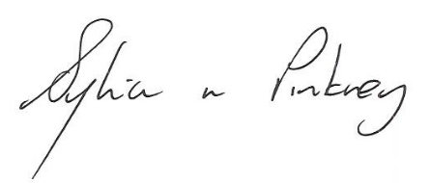

Sylvia Pinkney
Assistant Director, (Regulatory Services)

The Licensing Section
Public Protection Division
Hartlepool Borough Council
Civic Centre
Victoria Road
Hartlepool
TS24 8AY

