Part B

Club premises certificate summary

Hartlepool Borough Council

Club premises certificate number
HART/CL/004

Club Details

Name of club in whose name the certificate is granted and relevant registered postal address of club
Hartlepool United Supporters Club

Address Sandringham Road

Post town Hartlepool | Post code TS26 8PS
Telephone number 01429 274333

If different from above the postal address of club premises to which the certificate relates, or if none, ordnance survey map reference or description

N/A

Post town | Post code
Telephone number

Where the club premises certificate is time limited the dates

N/A

Qualifying club activities authorised by the certificate

Supply of alcohol to members or guests

The provision of Live/Recorded music and facilities for dancing

The times the certificate authorises the carrying out of qualifying club activities

Supply of Alcohol

On Licence: Monday to Sunday 11:00 - 23:59
Christmas Eve and New Year’s Eve 11:00 – 02:00 (the following morning)
The Beer Garden is restricted to Monday – Sunday 11:00 – 19:00

Entertainment

Live and Recorded Music Monday – Sunday 19:00 – 23:59
Christmas Eve and New Year’s Eve 11:00 – 01:00 (the following morning)

Dancing facilities: Monday to Sunday 11:00 – 23:59
Christmas Eve and New Year’s Eve 11:00 – 01:00 (the following morning)

The opening hours of the club

At the discretion of the club

Where the certificate authorises supplies of alcohol whether these are on and/or off supplies

On Supplies

State whether access to the club premises by children is restricted or prohibited

Restricted

Date Licence Granted: 29th April 2021

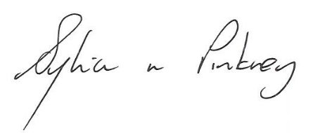

The Licensing Section
Public Protection Division
Hartlepool Borough Council
Civic Centre
Victoria Road
Hartlepool
TS24 8AY

