
THE LICENSING ACT 2003

PREMISES LICENCE SUMMARY (PART B)

Premises licence number | HART/PS/561

Premises details
Postal address of premises or, if none, ordnance survey map reference, or description

7 Scarborough Street

Post Town Hartlepool | Post Code TS24 7DA

Telephone number

Where the licence is time limited the dates

Licensable activities authorised by the licence. Any entertainment authorised by this licence is limited to indoors only, unless stated otherwise.

Alcohol Sales (on sales)

This licence does not authorise the provision of adult entertainment.

The times the licence authorises the carrying out of licensable activities

Monday – Saturday 09:00 – 24:00
Sunday 09:00 – 22:00

The opening hours of the premises

Monday – Saturday 09:00 – 24:00
Sunday 09:00 – 22:00

Where the licence authorises supplies of alcohol whether these are on and / or off supplies

On Sales

Name, (registered) address of holder of premises licence

Mrs Nicola Burrows
14 St. Begas Glade
Hartlepool
TS26 0FB

Registered number of holder, for example company number, charity number (where applicable)

N/A

Name of designated premises supervisor where the premises licence authorises for the supply of alcohol

Mr Neil Bianco

State whether access to the premises by children is restricted or prohibited

Restricted

Date Licence Granted: 24th March 2020

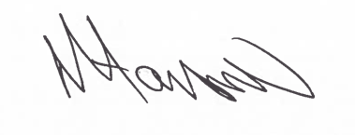

Tony Hanson
Assistant Director
(Environment & Neighbourhood Services)

The Licensing Section
Hartlepool Borough Council
Civic Centre
Victoria Road
Hartlepool
TS24 8AY

