

THE LICENSING ACT 2003

PREMISES LICENCE SUMMARY (PART B)

Premises licence number | HART/PS/559

Premises details
Postal address of premises or, if none, ordnance survey map reference, or description
6 Scarborough Street

Post Town Hartlepool | Post Code TS24 7DA

Telephone number 07939275620

Where the licence is time limited the dates

Licensable activities authorised by the licence. Any entertainment authorised by this licence is limited to indoors only, unless stated otherwise.

1. Supply of Alcohol
This licence does not authorise the provision of adult entertainment.

The times the licence authorises the carrying out of licensable activities

1. Supply of Alcohol Monday – Saturday 09:00 – 24:00
Sunday 10:00 – 22:00

The opening hours of the premises

Monday – Saturday 09:00 – 24:00
Sunday 10:00 – 22:00

Where the licence authorises supplies of alcohol whether these are on and / or off supplies
On & Off Sales

Name, (registered) address of holder of premises licence

Mr Neil Bianco
39 Eamont Gardens
Hartlepool
TS26 9JD

Registered number of holder, for example company number, charity number (where applicable)

N/A

Name of designated premises supervisor where the premises licence authorises for the supply of alcohol

Neil Bianco

State whether access to the premises by children is restricted or prohibited

Restricted

Date Licence Granted: 30th May 2020
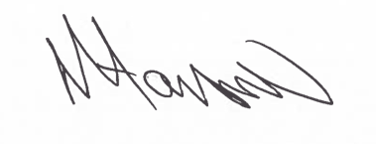
Licence Authorised by:

Tony Hanson
Assistant Director
(Environment and Neighbourhood Services)

The Licensing Section
Public Protection Division
Hartlepool Borough Council
Civic Centre
Victoria Road
Hartlepool
TS24 8AY

