

THE LICENSING ACT 2003

PREMISES LICENCE SUMMARY (PART B)

Premises licence number | HART/513

Premises details
Postal address of premises or, if none, ordnance survey map reference, or description
2 The Front
Seaton Carew

Post Town Hartlepool | Post Code TS25 1BS

Telephone number

Where the licence is time limited the dates

Licensable activities authorised by the licence. Any entertainment authorised by this licence is limited to indoors only, unless stated otherwise.

Supply of Alcohol
Live Music (Acoustic only)
Late Night Refreshment

This licence does not authorise the provision of adult entertainment.

The times the licence authorises the carrying out of licensable activities

Supply of Alcohol

Monday to Sunday 10:00 – 22:50
On Christmas Eve, Boxing Day and New Years Eve licensable activity can finish at 24:00

Live Music (Acoustic Only)

One occasion per week 19:00 – 22:00

The opening hours of the premises

Monday to Sunday 10:00 – 23:00
On Christmas Eve, Boxing Day and New Years Eve closing time can finish at 01:00

Where the licence authorises supplies of alcohol whether these are on and / or off supplies

On Sales Only

Name, (registered) address of holder of premises licence

Mr Peter Charlton
Room 25
Sunnyfield House Community Centre
36 West gate
Guisbrough
TA14 6BA

Registered number of holder, for example company number, charity number (where applicable)

Name of designated premises supervisor where the premises licence authorises for the supply of alcohol

Peter Charlton

State whether access to the premises by children is restricted or prohibited

Restricted

Date Licence Granted: 10th February 2022

Licence Authorised by: 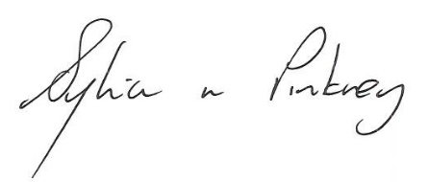

Sylvia Pinkney, Assistant Director
(Regulatory Services)

The Licensing Section
Hartlepool Borough Council
Civic Centre
Victoria Road
Hartlepool
TS24 8AY

