THE LICENSING ACT 2003

PREMISES LICENCE SUMMARY (PART B)

Premises licence number | HART/PS/035

Premises details

Postal address of premises or, if none, ordnance survey map reference, or description

Golden River
26 The Front
Seaton Carew

Post Town Hartlepool | Post code TS25 1BS

Telephone number 01429 268591

Where the licence is time limited the dates

N/A

Licensable activities authorised by the licence

Late Night Refreshment

The times the licence authorises the carrying out of licensable activities

Late Night Refreshment

Monday to Sunday 2300 - 0000

The opening hours of the premises

Sunday – Thursday 1700 – 0000
Friday – Saturday 1130 – 1400
1700 – 0000

Where the licence authorises supplies of alcohol whether these are on and / or off supplies

N/A

Name, (registered) address of holder of premises licence

Mr MingXiang Yu
26 The Front
Seaton Carew
Hartlepool
TS25 1BS

Registered number of holder, for example company number, charity number (where applicable)

N/A

Name of designated premises supervisor where the premises licence authorises for the supply of alcohol
N/A

State whether access to the premises by children is restricted or prohibited

Unrestricted

Date licence granted: 27th November 2019

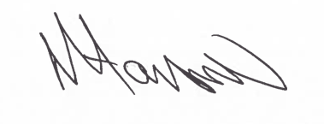
Tony Hanson
Assistant Director
(Environment & Neighbourhood Services)

The Licensing Section
Public Protection Division
Hartlepool Borough Council
Civic Centre
Victoria Road
Hartlepool
TS24 8AY

