THE LICENSING ACT 2003

PREMISES LICENCE SUMMARY (PART B)

Premises licence number | HART/PS/025

Premises details

Postal address of premises or, if none, ordnance survey map reference, or description

Allsorts
33 The Front
Seaton Carew

Post Town Hartlepool | Post code TS25 1BS

Telephone number 01429 266198

Where the licence is time limited the dates

N/A

Licensable activities authorised by the licence. Any entertainment authorised by this licence is limited to indoors only, unless stated otherwise.

Alcohol Sales

The times the licence authorises the carrying out of licensable activities

Alcohol Sales – Off Sales

Monday – Saturday 0800 – 2300
Sunday 1000 – 2230
Good Friday 0800 – 2230
Christmas Day 1200 – 1500
0900 – 2230

The opening hours of the premises

At the discretion of the licence holder

Where the licence authorises supplies of alcohol whether these are on and / or off supplies

Off Supplies

Name, (registered) address of holder of premises licence

Carol Ann Corbett
Allsorts
33 The Front
Seaton Carew
Hartlepool
TS25 1BS

Registered number of holder, for example company number, charity number (where applicable)

N/A

Name of designated premises supervisor where the premises licence authorises for the supply of alcohol

TBC

State whether access to the premises by children is restricted or prohibited

Unrestricted

Date licence granted: 7th November 2018

Licence Authorised by:
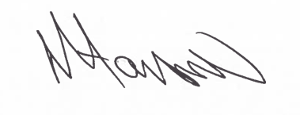

Tony Hanson, Assistant Director
(Environment and Neighbourhood Services)

The Licensing Section
Public Protection and Housing
Hartlepool Borough Council
Civic Centre
Victoria Road
Hartlepool
TS24 8AY

