

THE LICENSING ACT 2003

PREMISES LICENCE SUMMARY (PART B)

Premises licence number | HART/PS/410

Premises details
Postal address of premises or, if none, ordnance survey map reference, or description
36 The Front
Seaton Carew

Post Town Hartlepool | Post Code TS25 1BS

Telephone number 01429 222128

Where the licence is time limited the dates
N/A

Licensable activities authorised by the licence. Any entertainment authorised by this licence is limited to indoors only, unless stated otherwise.

1 | Supply of alcohol
2 | Late Night Refreshments

This licence does not authorise the provision of adult entertainment.

The times the licence authorises the carrying out of licensable activities

1 Supply of alcohol
2 Late Night Refreshment

Monday – Sunday 11:00 – 23:00

(on any day when Hartlepool Borough Council’s annual fireworks event takes
place - 23:00 – 24:00)

The opening hours of the premises

Monday – Sunday 08:00 – 23:00

(on any day when Hartlepool Borough Council’s annual fireworks event takes
place – 08:00 – 24:00)

Where the licence authorises supplies of alcohol whether these are on and / or off supplies

On sales only

Name, (registered) address of holder of premises licence

Mr Shane Atkinson
20 Coniscliffe Road
Hartlepool
TS26 0BT

Registered number of holder, for example company number, charity number (where applicable)

N/A

Name of designated premises supervisor where the premises licence authorises for the supply of alcohol

Mr Shane Atkinson

State whether access to the premises by children is restricted or prohibited

Restricted

Date Licence Granted: 10th September 2021

Licence Authorised by:

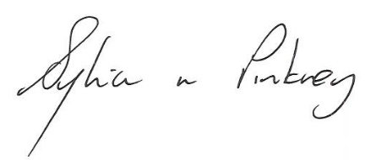
Sylvia Pinkney
Assistant Director
(Regulatory Services)

The Licensing Section
Public Protection Division
Hartlepool Borough Council
Civic Centre
Victoria Road
Hartlepool
TS24 8AY

