THE LICENSING ACT 2003

PREMISES LICENCE SUMMARY (PART B)

Premises licence number | HART/PS/571

Premises details
Postal address of premises or, if none, ordnance survey map reference, or description
76-77 The Front
Seaton Carew

Post Town Hartlepool | Post Code TS25 1BU

Telephone number (01429) 275220

Where the licence is time limited the dates

N/A

Licensable activities authorised by the licence. Any entertainment authorised by this licence is limited to indoors only, unless stated otherwise.

Alcohol Sales (On & Off Sales) & Recorded Music

This licence does not authorise the provision of adult entertainment.

The times the licence authorises the carrying out of licensable activities

Alcohol (On & Off Sales) Monday – Sunday 11:00 – 23:00
Recorded Music Monday – Sunday 09:00 – 23:00

Activities extended to 0:30 on New Years Eve

The opening hours of the premises

Monday – Sunday 09:00 – 23:30
Closing Time extended to 01:00 on New Years Eve

Where the licence authorises supplies of alcohol whether these are on and / or off supplies
On & Off sales

Name, (registered) address of holder of premises licence

Mrs Michelle Lane
76-77 The Front
Seaton Carew
Hartlepool
TS25 1BU

Registered number of holder, for example company number, charity number (where applicable)

N/A

Name of designated premises supervisor where the premises licence authorises for the supply of alcohol

Mrs Michelle Lane

State whether access to the premises by children is restricted or prohibited

N/A

Date Licence Granted: 29th April 2021

Licence Authorised by:

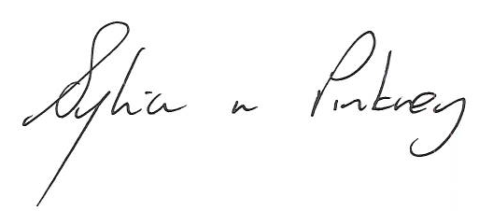

Sylvia Pinkney, Assistant Director
(Regulatory Services)

he Licensing Section
Hartlepool Borough Council
Civic Centre
Victoria Road
Hartlepool
TS24 8AY

