THE LICENSING ACT 2003

PREMISES LICENCE SUMMARY (PART B)

Premises licence number | HART/PS/122

Premises details

Postal address of premises or, if none, ordnance survey map reference, or description

The Pier
Britannia House
Slake Terrace

Post Town Hartlepool | Post code TS24 0YB

Telephone number

Where the licence is time limited the dates

N/A

Licensable activities authorised by the licence

Alcohol Sales - On and Off sales

Late Night Refreshment

The times the licence authorises the carrying out of licensable activities

Alcohol Sales & Late Night Refreshment

Monday – Saturday 11:00 – 00:00
Sunday 12:00 – 23:30

Christmas Day 12:00 – 23:30
Good Friday 12:00 – 23:30

The opening hours of the premises

At the discretion of the licensee

Where the licence authorises supplies of alcohol whether these are on and / or off supplies

On and Off sales

Name, (registered) address of holder of premises licence

Excel Leisure NE Ltd
2 Highgate Mews
Blackhill
Consett
County Durham
DH8 8RH

Registered number of holder, for example company number, charity number (where applicable)

14028393

Name of designated premises supervisor where the premises licence authorises for the supply of alcohol
Mr Daniel Mark Spoors

State whether access to the premises by children is restricted or prohibited

Restricted

Date licence granted: 4th May 2022

Licence Authorised by:
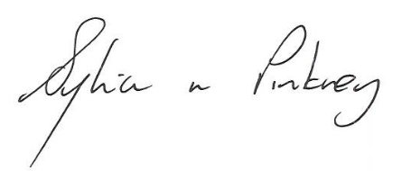

Sylvia Pinkney
Assistant Director
(Regulatory Services)

The Licensing Section
Public Protection Division
Hartlepool Borough Council
Civic Centre
Victoria Road
Hartlepool
TS24 8AY

