THE LICENSING ACT 2003

PREMISES LICENCE SUMMARY (PART B)

Premises licence number | HART/PS/242

Premises details

Postal address of premises or, if none, ordnance survey map reference, or description

The Harbour View
Abdiel House, Navigation Point

Post Town Hartlepool | Post Code TS24 0RU

Telephone number 01429 716100

Where the licence is time limited the dates

N/A

Licensable activities authorised by the licence. Any entertainment authorised by this licence is limited to indoors only, unless stated otherwise.

Alcohol Sales
On & Off Sales

Late Night Refreshment

The times the licence authorises the carrying out of licensable activities

1. Alcohol Sales (On & Off Sales)

2. Late Night Refreshment

Monday to Saturday 11:00 – 00:00
Sunday 12:00 – 23:30

Christmas Day 12:00 – 23:30
Good Friday 12:00 – 23:30

The opening hours of the premises

At the discretion of the Licence Holder

Where the licence authorises supplies of alcohol whether these are on and / or off supplies

On & Off Sales

Name, (registered) address of holder of premises licence

Mr Darab Rezai
Three Gates Farm
Dalton Piercy
Hartlepool
TS27 3HW

Registered number of holder, for example company number, charity number (where applicable)

N/A

Name of designated premises supervisor where the premises licence authorises for the supply of alcohol

Mr Darab Rezai

State whether access to the premises by children is restricted or prohibited

Restricted

Date Licence Granted: 5th November 2020

Licence Authorised by:

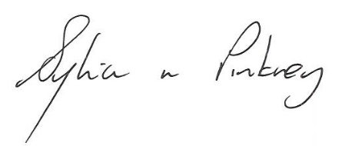
Sylvia Pinkney
Assistant Director
(Regulatory Services)

The Licensing Section
Public Protection Division
Hartlepool Borough Council
Civic Centre
Victoria Road
Hartlepool
TS24 8AY

