THE LICENSING ACT 2003

PREMISES LICENCE SUMMARY (PART B)

Premises licence number | HART/PS/187

Premises details
Postal address of premises or, if none, ordnance survey map reference, or description
Fishermans Arms
Southgate

Post Town Hartlepool | Post Code TS24 0JJ

Telephone number

Where the licence is time limited the dates

N/A

Licensable activities authorised by the licence. Any entertainment authorised by this licence is limited to indoors only, unless stated otherwise.

Supply of Alcohol (On & Off Licence) and Recorded Music

The times the licence authorises the carrying out of licensable activities

Supply of Alcohol (On & Off Licence) and Recorded Music

For all the above activities
Monday to Saturday 1100 – 2400
Sunday 1200 – 2330

All of the above activities may continue for one additional hour as follows:
Friday, Saturday, Sunday & Monday of Spring/Whitsun & August Bank Holiday
Thursday, Friday, Saturday, Sunday & Monday of Easter weekend
Christmas Eve
Boxing Day

The opening hours of the premises

Monday to Saturday 1100 – 0030
Sunday 1200 – 2400
When hours for sale of alcohol are extended for Bank Holidays, Christmas Eve and Boxing Day, these hours are also extended by one hour.

Where the licence authorises supplies of alcohol whether these are on and / or off supplies

On & Off Sales

Name, (registered) address of holder of premises licence

Mr Glenn Andrew Murphy
119 Chester Road
Hartlepool
TS26 0HZ

Registered number of holder, for example company number, charity number (where applicable)

N/A

Name of designated premises supervisor where the premises licence authorises for the supply of alcohol

Mrs Hazel Whitelock

State whether access to the premises by children is restricted or prohibited

Restricted

Date Licence Granted: 17th November 2017

Licence Authorised by:
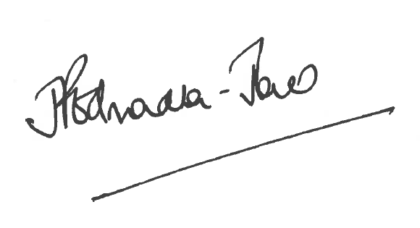
Director of Public Health

The Licensing Section
Public Protection
Hartlepool Borough Council
Civic Centre
Victoria Road
Hartlepool
TS24 8AY

