THE LICENSING ACT 2003

PREMISES LICENCE SUMMARY (PART B)

Premises licence number | HART/PS/068

Premises details

Postal address of premises or, if none, ordnance survey map reference, or description

Lotus Palace
139 Stockton Road

Post Town Hartlepool | Post code TS25 1SL

Telephone number 01429 269915

Where the licence is time limited the dates

N/A

Licensable activities authorised by the licence. Any entertainment authorised by this licence is limited to indoors only, unless stated otherwise.

The Provision of Late Night Refreshment

The times the licence authorises the carrying out of licensable activities

Late Night Refreshment

Monday – Sunday 23:00– 23:45

The opening hours of the premises

Monday – Saturday 17:30 – 23:45
Sunday 18:00 – 23:45

Where the licence authorises supplies of alcohol whether these are on and / or off supplies

N/A

Name, (registered) address of holder of premises licence

Minxing Zheng
139 Stockton Road
Hartlepool
TS25 1SL

Registered number of holder, for example company number, charity number (where applicable)

N/A

Name of designated premises supervisor where the premises licence authorises for the supply of alcohol

N/A

State whether access to the premises by children is restricted or prohibited

Unrestricted

Date Licence Granted: 27th October 2017

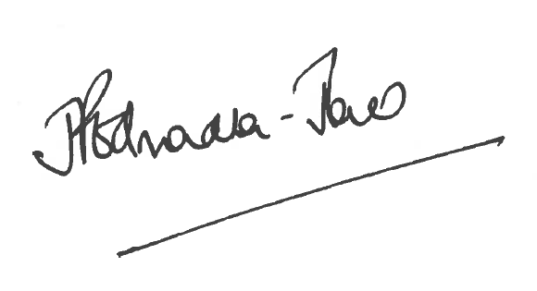
Director of Public Health

The Licensing Section
Public Protection and Housing
Hartlepool Borough Council
Civic Centre
Victoria Road
Hartlepool
TS24 8AY

