THE LICENSING ACT 2003

PREMISES LICENCE SUMMARY (PART B)

Premises licence number | HART/PS/006

Premises details

Postal address of premises or, if none, ordnance survey map reference, or description

The 11 O’Clock Shop
125 Stockton Road

Post Town Hartlepool | Post code TS25 1SL

Telephone number 01429 274641

Where the licence is time limited the dates

N/A

Licensable activities authorised by the licence

Alcohol Sales (Off-Licence)

The times the licence authorises the carrying out of licensable activities

Alcohol Sales (Off-Licence)

Monday – Sunday 08:00 – 23:00

The opening hours of the premises

Monday – Sunday 07:00 – 23:00

Where the licence authorises supplies of alcohol whether these are on and / or off supplies

Off Sales

Name, (registered) address of holder of premises licence

Devinder Malhotra
73 – 75 Kings Road
Normanby
Middlesbrough
TS3 6EY

Tel: 07837864985

Registered number of holder, for example company number, charity number (where applicable)

N/A

Name of designated premises supervisor where the premises licence authorises for the supply of alcohol

Devinder Malhotra

State whether access to the premises by children is restricted or prohibited

Unrestricted

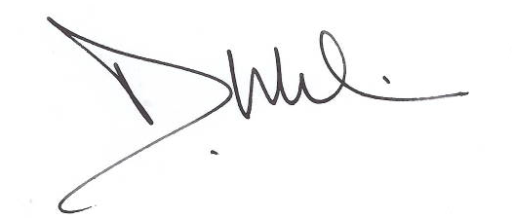
Licence Authorised By: ___________________________
Damien Wilson
Assistant Director
Regeneration and Planning

Date Licence Granted: 15th February 2011

The Licensing Section
Public Protection Division
Hartlepool Borough Council
Bryan Hanson House
Lynn Street
Hartlepool
TS24 7BT

