

THE LICENSING ACT 2003

PREMISES LICENCE SUMMARY (PART B)

Premises licence number | HART/PS/413

Premises details
Postal address of premises or, if none, ordnance survey map reference, or description
Hartlepool College of Further Education
Stockton Street

Post Town Hartlepool | Post Code TS24 7NT

Telephone number 01429 295111

Where the licence is time limited the dates
N/A

Licensable activities authorised by the licence. Any entertainment authorised by this licence is limited to indoors only, unless stated otherwise.

1 | Supply of alcohol | 2 | Plays
3 | Films | 4 | Indoor Sporting Events
5 | Live Music (Indoors & Outdoors) | 6 | Recorded Music
7 | Performance of dance | 8 | Provision of facilities for dancing
9 | Provision of late night refreshment

This licence does not authorise the provision of adult entertainment.

The times the licence authorises the carrying out of licensable activities

Supply of alcohol | Monday – Sunday 09:00 – 23:00
Live Music (Indoors & Outdoors) | Monday – Saturday 09:00 – 23:00  Sunday 09:00 – 22:00
Performance of dance | Monday – Sunday 09:00 – 23:00
Provision of facilities for dancing | Monday – Sunday 09:00 – 23:00
Plays | Monday – Sunday 09:00 – 22:00
Films | Monday – Sunday 09:00 – 22:00
Indoor Sporting Events | Monday – Saturday 09:00 – 22:00  Sunday 09:00 – 21:00
Recorded Music | Monday – Saturday 09:00 – 22:00  Sunday 09:00 – 21:00
Provision of Late Night Refreshments | Monday – Sunday 23:00 – 01:00

The opening hours of the premises

Monday – Saturday | 08:30 – 01:00
Sunday | 09:00 – 01:00

Where the licence authorises supplies of alcohol whether these are on and / or off supplies

On sales only

Name, (registered) address of holder of premises licence

Hartlepool College of Further Education
Stockton Street
Hartlepool Tel: 01429 295111

Registered number of holder, for example company number, charity number (where applicable)

N/A

Name of designated premises supervisor where the premises licence authorises for the supply of alcohol

Deborah Caygill

State whether access to the premises by children is restricted or prohibited

Restricted

Date Licence Granted: 04th November 2021
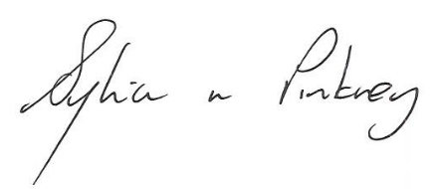
Sylvia Pinkney
Assistant Director
(Regulatory Services)

The Licensing Section
Public Protection Division
Hartlepool Borough Council
Civic Centre
Victoria Road
Hartlepool
TS24 8AY

