THE LICENSING ACT 2003

PREMISES LICENCE SUMMARY (PART B)

Premises licence number | HART/PS/339

Premises details
Postal address of premises or, if none, ordnance survey map reference, or description

2 Sydenham Road

Post Town Hartlepool | Post Code TS25 1QB

Telephone number 01429 597997

Where the licence is time limited the dates

N/A

Licensable activities authorised by the licence. Any entertainment authorised by this licence is limited to indoors only, unless stated otherwise.

Supply of Alcohol

The times the licence authorises the carrying out of licensable activities

Monday to Friday 09:00 – 22:00
Saturday and Sunday 09:00 – 22:00

The opening hours of the premises

Monday to Friday 09:00 – 22:00
Saturday and Sunday 10:00 – 22:00

Where the licence authorises supplies of alcohol whether these are on and / or off supplies

Off Sales

Name, (registered) address of holder of premises licence

Savior Selvarasa & Janarthani Paramesvaran
2 Sydenham Road
Hartlepool
TS25 1QB

Registered number of holder, for example company number, charity number (where applicable)

Name of designated premises supervisor where the premises licence authorises for the supply of alcohol

Janarthani Paramesvaran

State whether access to the premises by children is restricted or prohibited

Unrestricted

Date Licence Granted: 21st January 2022

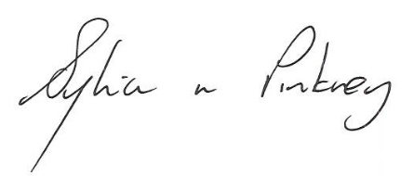

The Licensing Section
Public Protection Division
Hartlepool Borough Council
Civic Centre
Victoria Road
Hartlepool
TS24 8AY

