THE LICENSING ACT 2003

PREMISES LICENCE SUMMARY (PART B)

Premises licence number | HART/PS/155

Premises details

Postal address of premises or, if none, ordnance survey map reference, or description

Unit 2 Tees Bay Retail Park, Brenda Road

Post Town Hartlepool | Post code TS25 1XH

Telephone number 01827 710800

Where the licence is time limited the dates

N/A

Licensable activities authorised by the licence

Alcohol Sales

Off sales

The times the licence authorises the carrying out of licensable activities

Alcohol Sales

Off sales Monday – Saturday 0800 – 2300
Sunday 1000 – 2230
Christmas Day 1200 – 1500
1900 – 2230
Good Friday 0800 – 2230

The opening hours of the premises

At the discretion of the licensee

Where the licence authorises supplies of alcohol whether these are on and / or off supplies

Off sales

Name, (registered) address of holder of premises licence

Aldi Stores Limited
Holly Lane
Atherstone
Warwickshire
CV9 2SQ

Registered number of holder, for example company number, charity number (where applicable)

2321869

Name of designated premises supervisor where the premises licence authorises for the supply of alcohol
Faye Hunter

State whether access to the premises by children is restricted or prohibited

Unrestricted

Date licence granted: 17th October 2019

Licence Authorised by:

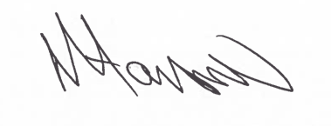
Tony Hanson
Assistant Director
(Environment & Neighbourhood Services)

The Licensing Section
Public Protection
Hartlepool Borough Council
Civic Centre
Victoria Road
Hartlepool
TS24 8AY

