
THE LICENSING ACT 2003

PREMISES LICENCE SUMMARY (PART B)

Premises licence number | HART/PS/560

Premises details
Postal address of premises or, if none, ordnance survey map reference, or description
Lyla Belle’s Ltd
Unit 13 Teesbay Retail Park

Post Town Hartlepool | Post Code TS24 1XJ

Telephone number 07979 612204

Where the licence is time limited the dates

Licensable activities authorised by the licence. Any entertainment authorised by this licence is limited to indoors only, unless stated otherwise.

1. Recorded Music
2. Supply of Alcohol (On Sales)
3. Live Music

This licence does not authorise the provision of adult entertainment.

The times the licence authorises the carrying out of licensable activities

1. Recorded Music Mon – Sat 09:00 – 19:00
Sun 10:00 – 17:00

2. Supply of Alcohol Mon – Sun 10:00 – 22:30
(On Sales)

3. Live Music Sat 18:00 – 22:00

For Christmas Eve & New Year’s Eve the sale of alcohol can start at 09:00 – 16:00

The opening hours of the premises

Mon – Sun 09:00 – 22:30

Where the licence authorises supplies of alcohol whether these are on and / or off supplies

On Sales

Name, (registered) address of holder of premises licence

Lyla Belle’s Ltd
Unit 13
Teesbay Retails Park
Hartlepool
TS25 1XJ

Registered number of holder, for example company number, charity number (where applicable)

12256996

Name of designated premises supervisor where the premises licence authorises for the supply of alcohol

Emily Jane Whitfield

State whether access to the premises by children is restricted or prohibited

Restricted

Date Licence Granted: 19th November 2021

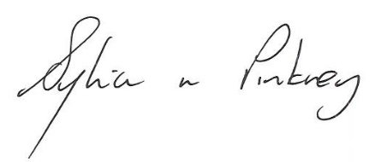
Sylvia Pinkney
Assistant Director
(Regulatory Services)

The Licensing Section, Public Protection Division, Hartlepool Borough Council, Civic Centre, Victoria Road, Hartlepool, TS24 8AY

