

THE LICENSING ACT 2003

PREMISES LICENCE SUMMARY (PART B)

Premises licence number | HART/PS/511

Premises details
Postal address of premises or, if none, ordnance survey map reference, or description
11 Tower Street

Post Town Hartlepool | Post Code TS24 7HH

Telephone number

Where the licence is time limited the dates

N/A

Licensable activities authorised by the licence. Any entertainment authorised by this licence is limited to indoors only, unless stated otherwise.

1. | Supply of Alcohol
2. | Recorded Music

This licence does not authorise the provision of adult entertainment.

The times the licence authorises the carrying out of licensable activities

Monday to Sunday 11:00 – 23:00

The opening hours of the premises

Monday to Sunday 11:00 – 23:00

Where the licence authorises supplies of alcohol whether these are on and / or off supplies

On and Off Sales

Name, (registered) address of holder of premises licence

Darrell Peter Slater
22 Lansdowne Road
Hartlepool
TS26 9JL

Registered number of holder, for example company number, charity number (where applicable)

N/A

Name of designated premises supervisor where the premises licence authorises for the supply of alcohol

Darrell Peter Slater

State whether access to the premises by children is restricted or prohibited

Restricted

Date Licence Granted: 10th March 2022

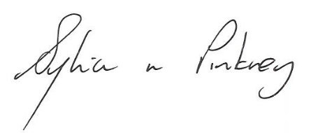

Sylvia Pinkney
Assistant Director
(Regulatory Services)

The Licensing Section
Public Protection Division
Hartlepool Borough Council
Civic Centre
Victoria Road
Hartlepool
TS24 8AY

