

THE LICENSING ACT 2003

PREMISES LICENCE SUMMARY (PART B)

Premises licence number | HART/PS/582

Premises details
Postal address of premises or, if none, ordnance survey map reference, or description

Big Bamboo
Ground Floor
12 Tower Street

Post Town Hartlepool | Post Code TS24 7HD

Telephone number 01429 861555

Where the licence is time limited the dates
N/A

Licensable activities authorised by the licence. Any entertainment authorised by this licence is limited to indoors only, unless stated otherwise.

Supply of Alcohol

This licence does not authorise the provision of adult entertainment.

The times the licence authorises the carrying out of licensable activities

Monday to Sunday 08:00 – 20:00

Monday to Sunday 08:00 – 20:00

Where the licence authorises supplies of alcohol whether these are on and / or off supplies

On Sales Only

Name, (registered) address of holder of premises licence

Andrew James Richardson
35 Meadowgate Drive
Hartlepool
TS26 0RH

Registered number of holder, for example company number, charity number (where applicable)

N/A

Name of designated premises supervisor where the premises licence authorises for the supply of alcohol

Andrew James Richardson

State whether access to the premises by children is restricted or prohibited

Unrestricted

Date Licence Granted: 25th April 2022

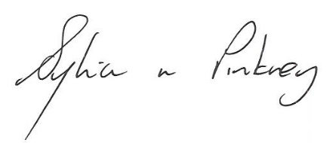

Sylvia Pinkney,
Assistant Director
(Regulatory Services)

The Licensing Section
Public Protection Division
Hartlepool Borough Council
Civic Centre
Victoria Road
Hartlepool
TS24 8AY

