Part B

Club Premises Certificate
Summary

Certificate number
HART/CL/043

Club details
Name of club in whose name the certificate is granted and relevant registered postal address of club
Hartlepool Rovers Football Club

Address
The Friarage
West View Road

Post town Hartlepool | Post code TS24 0BP
Telephone number 01429 267741

If different from above the postal address of club premises to which the certificate relates, or if none, ordnance survey map reference or description

N/A

Post town | Post code

Telephone number

Where the club premises certificate is time limited the dates

N/A

Qualifying club activities authorised by the certificate. Any entertainment authorised by this certificate is limited to indoors only, unless stated otherwise.

1. Supply of Alcohol
2. Indoor Sporting Events
3. Live Music
4. Recorded Music
5. Anything of a similar description to 3 & 4 above
6. Provision of Facilities for Making Music
7. Provision of Facilities for Dancing
8. Provision of facilities for anything similar to 6 & 7 above

The times the certificate authorises the carrying out of qualifying club activities

1. Supply of Alcohol All licensed activities
2. Indoor Sporting Events
3. Live Music Mon – Thu 1100 – 0000
4. Recorded Music Fri – Sat 1100 – 0200
5. Anything of a similar Sunday 1200 – 2300
description to 3 & 4 above
6. Provision of Facilities for Making Music
7. Provision of Facilities for Dancing
8. Provision of facilities for
anything similar to 6 & 7 above

The opening hours of the club

At the discretion of the club

Where the certificate authorises supplies of alcohol whether these are on and/or off supplies
On & Off Supplies

State whether access to the club premises by children is restricted or prohibited

Restricted

Date licence granted: 22nd September 2005

Licence Authorised by:

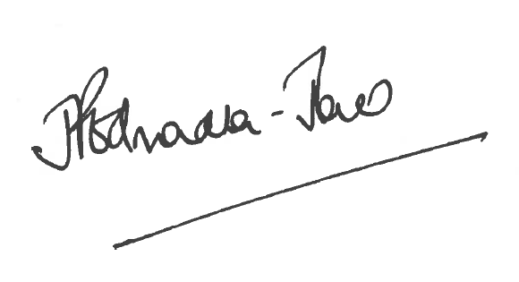
Director of Public Health

The Licensing Section
Public Protection and Housing
Hartlepool Borough Council
Civic Centre
Victoria Road
Hartlepool
TS24 8AY

