

THE LICENSING ACT 2003

PREMISES LICENCE SUMMARY (PART B)

Premises licence number | HART/PS/480

Premises details
Postal address of premises or, if none, ordnance survey map reference, or description
Red Dreams
The Pluto Room
Unit 5
110 Whitby Street South

Post Town Hartlepool | Post Code TS24 7LP

Telephone number 01429 894605

Where the licence is time limited the dates

N/A

Licensable activities authorised by the licence. Any entertainment authorised by this licence is limited to indoors only, unless stated otherwise.

1. Supply of Alcohol
2. Plays
3. Films
4. Indoor Sporting Events
5. Live Music
6. Recorded Music
7. Dance
8. Anything similar to 5, 6 or 7

This licence does not authorise the provision of adult entertainment.

The times the licence authorises the carrying out of licensable activities

1. Supply of Alcohol Monday – Friday 18:00 – 23:00
Saturday - Sunday 12:00 – 15:00
18:00 – 23:00
2. Plays Monday – Sunday 10:00 – 23:00
3. Films Monday – Sunday 10:00 – 23:00
4. Indoor Sporting Events Monday – Sunday 10:00 – 23:00
5. Live Music Monday – Sunday 10:00 – 23:00
6. Recorded Music Monday – Sunday 10:00 – 23:00
7. Dance Monday – Sunday 10:00 – 23:00
8. Anything similar Monday – Sunday 10:00 – 23:00

The opening hours of the premises

Monday – Sunday 10:00 – 23:00

Where the licence authorises supplies of alcohol whether these are on and / or off supplies

On Sales

Name, (registered) address of holder of premises licence

Red Dreams CIO
Unit 5
The Pluto Room
110 Whitby Street South
Hartlepool
TS24 7LP

Registered number of holder, for example company number, charity number (where applicable)

N/A

Name of designated premises supervisor where the premises licence authorises for the supply of alcohol

Kelly Anne Robson

State whether access to the premises by children is restricted or prohibited
Restricted

Date Licence Granted: 20th February 2017

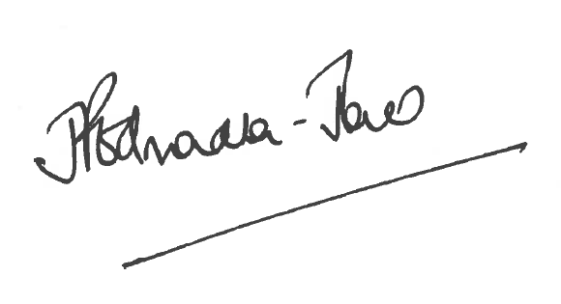

Director of Public Health

The Licensing Section
Hartlepool Borough Council
Civic Centre
Victoria Road
Hartlepool
TS24 8AY

