

THE LICENSING ACT 2003

PREMISES LICENCE SUMMARY (PART B)

Premises licence number | HART/PS/574

Premises details

Postal address of premises or, if none, ordnance survey map reference, or description

High Throston Golf Course
Worset Lane

Post Town Hartlepool | Post code TS26 0UG

Telephone number 01429 275325 Mobile 07805723177

Where the licence is time limited the dates

N/A

Licensable activities authorised by the licence

Alcohol Sales – (On Sale)

The times the licence authorises the carrying out of licensable activities

Alcohol Sales Monday - Sunday 12:00 – 20:00

The opening hours of the premises

Monday - Sunday 06:30 – 20:30

Where the licence authorises supplies of alcohol whether these are on and / or off supplies

On Sales

Name, (registered) address of holder of premises licence

Mrs Kelly Forcer
High Throston Golf Course
Managers House
Worset Lane
Hartlepool
TS26 0UG

Registered number of holder, for example company number, charity number (where applicable)

N/A

Name of designated premises supervisor where the premises licence authorises for the supply of alcohol
Mrs Kelly Forcer

State whether access to the premises by children is restricted or prohibited

Restricted

Date licence granted: 10th December 2021

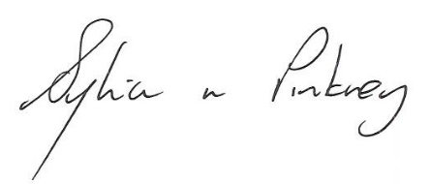

Sylvia Pinkney
Assistant Director
(Regulatory Services)

The Licensing Section
Public Protection Division
Hartlepool Borough Council
Civic Centre
Victoria Road
Hartlepool
TS24 8AY

