Part B

Club Premises Certificate
Summary

Certificate number
HART/CL/036

Club details
Name of club in whose name the certificate is granted and relevant registered postal address of club

Owton Manor Social Club CIC

Address Wynyard Road

Post town Hartlepool | Post code TS25 3LQ
Telephone number 01429 274729

If different from above the postal address of club premises to which the certificate relates, or if none, ordnance survey map reference or description

N/A

Post town | Post code

Telephone number

Where the club premises certificate is time limited the dates

N/A

Qualifying club activities authorised by the certificate. Any entertainment authorised by this certificate is limited to indoors only, unless stated otherwise.

Supply of Alcohol (On & Off Supplies)

Entertainment
- Plays 6. Anything of similar description to 3, 4, and 5
- Indoor Sporting Events 7. Provision of facilities for making Music
- Live Music 8. Provision of facilities for Dancing
- Recorded Music 9. Provision of facilities of a similar description
- Performance of Dance to 7 & 8 above.

The times the certificate authorises the carrying out of qualifying club activities

Supply of Alcohol (On & Off Supplies)
Monday to Sunday 1100 – 2400

Entertainment
- Plays Monday to Sunday 1000 – 1500

- Indoor Sporting Events Monday to Sunday 11:00 – 00:00
- Live Music Monday to Sunday 11:00 – 00:00
- Recorded Music Monday to Sunday 11:00 – 00:00
- Performance of Dance Monday to Sunday 11:00 – 00:00
- Anything of a similar description Monday to Sunday 11:00 – 00:00
to 3, 4 and 5 above.
- Provision of facilities making Music Monday to Sunday 11:00 – 00:00
- Provision of facilities for Dancing Monday to Sunday 11:00 – 00:00
- Provision of facilities of a similar Monday to Sunday 11:00 – 00:00
description to 7 & 8 above. Monday to Sunday 11:00 – 00:00

The opening hours of the club

At the discretion of the club

Where the certificate authorises supplies of alcohol whether these are on and/or off supplies

On & Off Supplies

State whether access to the club premises by children is restricted or prohibited

Restricted

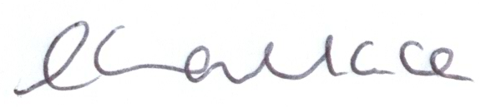

Licence Authorised By:

Louise Wallace
Director of Public Health

Date licence granted: 30th September 2013

The Licensing Section
Public Protection and Housing
Hartlepool Borough Council
Civic Centre
Victoria Road
Hartlepool
TS24 8AY

