

THE LICENSING ACT 2003

PREMISES LICENCE SUMMARY (PART B)

Premises licence number | HART/PS/567

Premises details
Postal address of premises or, if none, ordnance survey map reference, or description

Wynyard Road Service Station
47-49 Wynyard Road

Post Town Hartlepool | Post Code TS25 3LB

Telephone number

Where the licence is time limited the dates

N/A

Licensable activities authorised by the licence. Any entertainment authorised by this licence is limited to indoors only, unless stated otherwise.

- Alcohol Sales
- Late Night Refreshment

This licence does not authorise the provision of adult entertainment.

The times the licence authorises the carrying out of licensable activities

- Alcohol Sales Monday – Sunday 09:00 – 22:00
- Late Night Refreshment Monday – Sunday 23:00 – 05:00

The opening hours of the premises

Monday – Sunday 00:00 – 23:59

Where the licence authorises supplies of alcohol whether these are on and / or off supplies

Off Sales only

Name, (registered) address of holder of premises licence

Penny Petroleum (North East) Limited
Global House
303 Ballards Lane
London
N12 8NP

Registered number of holder, for example company number, charity number (where applicable)

07952926

Name of designated premises supervisor where the premises licence authorises for the supply of alcohol

Mr Gary Pitt

State whether access to the premises by children is restricted or prohibited

Unrestricted

Date Licence Granted: 6th January 2021

Licence Authorised by: 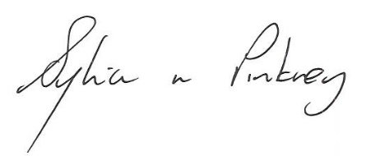

Sylvia Pinkney
Assistant Director, (Regulatory Services)

The Licensing Section
Public Protection Division
Hartlepool Borough Council
Civic Centre
Victoria Road
Hartlepool
TS24 8AY

