

THE LICENSING ACT 2003

PREMISES LICENCE SUMMARY (PART B)

Premises licence number | HART/PS/495

Premises details
Postal address of premises or, if none, ordnance survey map reference, or description
75 York Road

Post Town Hartlepool | Post Code TS26 8AH

Telephone number 07455164840

Where the licence is time limited the dates

N/A

Licensable activities authorised by the licence. Any entertainment authorised by this licence is limited to indoors only, unless stated otherwise.

Sale of Alcohol

This licence does not authorise the provision of adult entertainment.

The times the licence authorises the carrying out of licensable activities

Monday to Sunday 08:00 – 22:00

The opening hours of the premises

Monday to Sunday 08:00 – 22:00

Where the licence authorises supplies of alcohol whether these are on and / or off supplies

Off Sales

Name, (registered) address of holder of premises licence

Sivatharushan Sivapragasam
5 Grange Avenue
Billingham
TS23 1JQ

Tel: 07455164840 Email:sivatharushans@gmail.com

Registered number of holder, for example company number, charity number (where applicable)

N/A

Name of designated premises supervisor where the premises licence authorises for the supply of alcohol

Sivatharushan Sivapragasam

State whether access to the premises by children is restricted or prohibited

No Restrictions

Date Licence Granted: 20th November 2017

Licence Authorised by:

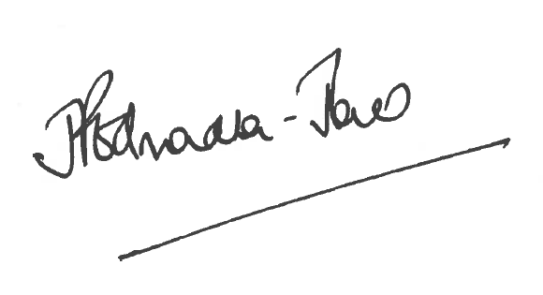
Director of Public Health

The Licensing Section
Hartlepool Borough Council
Civic Centre
Victoria Road
Hartlepool
TS24 8AY

