THE LICENSING ACT 2003

PREMISES LICENCE SUMMARY (PART B)

Premises licence number | HART/PS/271

Premises details

Postal address of premises or, if none, ordnance survey map reference, or description

King Kaz Pizzeria
98 York Road

Post Town Hartlepool | Post code TS26 9DQ

Telephone number 01429 682376

Where the licence is time limited the dates

N/A

Licensable activities authorised by the licence

Late Night Refreshment

The times the licence authorises the carrying out of licensable activities

Late Night Refreshment

Monday – Sunday 2300 – 0300

The opening hours of the premises

Monday – Sunday 2300 – 0300

Where the licence authorises supplies of alcohol whether these are on and / or off supplies

N/A

Name, (registered) address of holder of premises licence

Mr Muhammad Umar Arshad
98 York Road
Hartlepool
TS26 9DQ

Registered number of holder, for example company number, charity number (where applicable)

N/A

Name of designated premises supervisor where the premises licence authorises for the supply of alcohol

N/A

State whether access to the premises by children is restricted or prohibited

Unrestricted

Date licence granted: 21st November 2019

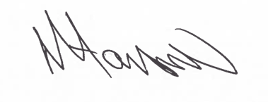
Assistant Director
(Environment & Neighbourhood Services)

The Licensing Department
Public Protection Division
Hartlepool Borough Council
Civic Centre
Victoria Road
Hartlepool
TS24 8AY

