

THE LICENSING ACT 2003

PREMISES LICENCE SUMMARY (PART B)

Premises licence number | HART/476

Premises details
Postal address of premises or, if none, ordnance survey map reference, or description
102 York Road

Post Town Hartlepool | Post Code TS26 9DE

Telephone number N/A

Where the licence is time limited the dates

N/A

Licensable activities authorised by the licence. Any entertainment authorised by this licence is limited to indoors only, unless stated otherwise.

Supply of Alcohol

This licence does not authorise the provision of adult entertainment.

The times the licence authorises the carrying out of licensable activities

Monday to Sunday 09:00 – 23:00

The opening hours of the premises

Monday to Thursday 09:00 – 17:00
Friday 09:00 – 17:00 & 18:30 – 23:00
Saturday 09:00 – 17:00

Where the licence authorises supplies of alcohol whether these are on and / or off supplies

On and Off Sales

Name, (registered) address of holder of premises licence

Jennifer Hart
163 Stockton Road
Hartlepool
TS25 1SL

Email: info@athart.co.uk Tel: 07981227669

Registered number of holder, for example company number, charity number (where applicable)

N/A

Name of designated premises supervisor where the premises licence authorises for the supply of alcohol

Jennifer Hart

State whether access to the premises by children is restricted or prohibited

Restricted

Date Licence Granted: 20th December 2014

Signed: 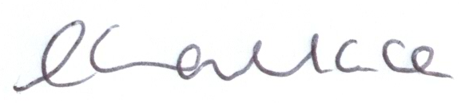

Director of Public Health

The Licensing Section
Hartlepool Borough Council
Civic Centre
Victoria Road
Hartlepool
TS24 8AY

