THE LICENSING ACT 2003

PREMISES LICENCE SUMMARY (PART B)

Premises licence number | HART/PS/359e

Premises details
Postal address of premises or, if none, ordnance survey map reference, or description

128 – 132 York Road

Post Town Hartlepool | Post Code TS26 9DA

Telephone number

Where the licence is time limited the dates
N/A

Licensable activities authorised by the licence. Any entertainment authorised by this licence is limited to indoors only, unless stated otherwise.

Supply of Alcohol

The times the licence authorises the carrying out of licensable activities

Monday to Sunday 06:00 – 23:00

The opening hours of the premises

Monday to Sunday 06:00 – 23:00

Where the licence authorises supplies of alcohol whether these are on and / or off supplies

Off Sales Only

Name, (registered) address of holder of premises licence

Tesco Stores Ltd
Tesco House
Delamare Road
Cheshunt
Waltham Cross
Herts
EN8 9SL

Registered number of holder, for example company number, charity number (where applicable)

00519500

Name of designated premises supervisor where the premises licence authorises for the supply of alcohol

Scott Andrew Britton

State whether access to the premises by children is restricted or prohibited

Unrestricted

Signed: 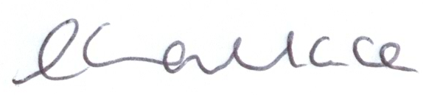

Director of Public Health

Date Licence Granted: 7th February 2014

The Licensing Section
Public Protection Division
Hartlepool Borough Council
Civic Centre
Victoria Road
Hartlepool
TS24 8AY

