THE LICENSING ACT 2003

PREMISES LICENCE SUMMARY (PART B)

Premises licence number | HART/PS/311

Premises details
Postal address of premises or, if none, ordnance survey map reference, or description
One 77
175-177 York Road

Post Town Hartlepool | Post Code TS26 9EQ

Telephone number 01429 862177

Where the licence is time limited the dates
N/A

Licensable activities authorised by the licence. Any entertainment authorised by this licence is limited to indoors only, unless stated otherwise.

Entertainment
- Plays 6. Anything of a similar description to 3, 4 or 5 above
- Films 7. Provision of facilities for Making Music
- Live Music 8. Provision of facilities for Dancing
4. Recorded Music 9. Provision of facilities for Entertainment similar to 7 5. Performance of Dance or 8 above
10. Supply of Alcohol

The times the licence authorises the carrying out of licensable activities

1. Plays 6. Anything of a similar description to 3, 4 or 5 above
2. Films 7. Provision of facilities for Making Music
3. Live Music 8. Provision of facilities for Dancing
4. Recorded Music 9. Provision of facilities for Entertainment similar to 7 5. Performance of Dance or 8 above
10. Supply of Alcohol

For all the above licensable activities: Monday – Saturdays 10:00 – 23:30
Sundays 12:00 – 22:30

The opening hours of the premises

Monday – Saturdays 08:30 – 23:30
Sundays 11:00 – 22:30

Where the licence authorises supplies of alcohol whether these are on and / or off supplies

N/A

Name, (registered) address of holder of premises licence

Families First (North East)
One 77
175 - 177 York Road
Hartlepool
TS26 9EQ

Tel: 01429 867016

Registered number of holder, for example company number, charity number (where applicable)

1002009

Name of designated premises supervisor where the premises licence authorises for the supply of alcohol

Mr Paul Thompson

State whether access to the premises by children is restricted or prohibited

Unrestricted

Date Licence Granted: 12th April 2017

Licence Authorised by:
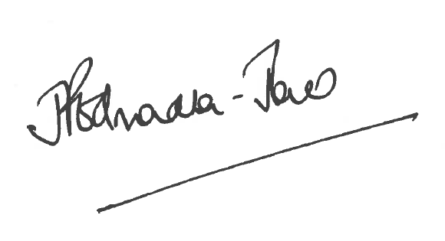
Director of Public Health

The Licensing Section
Hartlepool Borough Council
Civic Centre
Victoria Road
Hartlepool
TS24 8AY

