THE LICENSING ACT 2003

PREMISES LICENCE SUMMARY (PART B)

Premises licence number | HART/PS/003

Premises details

Postal address of premises or, if none, ordnance survey map reference, or description

The “New” York House
185 -187 York Road

Post Town Hartlepool | Post code TS26 9EE

Telephone number: 01429 867373

Where the licence is time limited the dates

N/A

Licensable activities authorised by the licence

Sale by retail of alcohol
Karaoke & Recorded Music

The times the licence authorises the carrying out of licensable activities

Alcohol Sales
On-Licence: Monday to Saturday – 11:00 – 00:00
Sunday - 12:00 – 23:30
Christmas Day – 12:00 – 23:30

Entertainment

Karaoke and Recorded Music: Monday to Sunday 19:00 – 00:00

Additional holiday hours as detailed in Part A of this Premises Licence

The opening hours of the premises

Unrestricted by this legislation

Where the licence authorises supplies of alcohol whether these are on and / or off supplies

On Sales

Name, (registered) address of holder of premises licence

Mr Lee Pennick
3 The Paddock
Seaton Carew
Hartlepool
TS25 1BY

Registered number of holder, for example company number, charity number (where applicable)

N/A

Name of designated premises supervisor where the premises licence authorises for the supply of alcohol

State whether access to the premises by children is restricted or prohibited

Restricted

Licence dated: 3rd June 2019

Licence Authorised by:
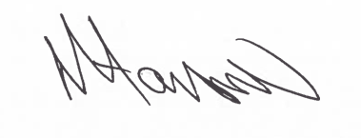

Tony Hanson, Assistant Director
(Environment and Neighbourhood Services)

The Licensing Section
Public Protection & Housing
Hartlepool Borough Council
Civic Centre
Victoria Road
Hartlepool
TS24 8AY

