THE LICENSING ACT 2003

PREMISES LICENCE SUMMARY (PART B)

Premises licence number | HART/PS/139

Premises details

Postal address of premises or, if none, ordnance survey map reference, or description

Tony’s Parmesan House
235 York Road

Post Town Hartlepool | Post code TS26 9AD

Telephone number 01429 860690

Where the licence is time limited the dates

N/A

Licensable activities authorised by the licence

Late Night Refreshment

The times the licence authorises the carrying out of licensable activities

Late Night Refreshment

Sunday – Thursday 2300 – 0000
Friday – Saturday 2300 – 0100

The opening hours of the premises

Sunday – Thursday 1100 – 0000
Friday – Saturday 1100 – 0100

Where the licence authorises supplies of alcohol whether these are on and / or off supplies

N/A

Name, (registered) address of holder of premises licence

Tony’s Parmesan Place York Road LTD
235 York Road
Hartlepool
TS26 9AD

Registered number of holder, for example company number, charity number (where applicable)

13260113

Name of designated premises supervisor where the premises licence authorises for the supply of alcohol
N/A

State whether access to the premises by children is restricted or prohibited

Unrestricted

Date licence granted: 3rd March 2022

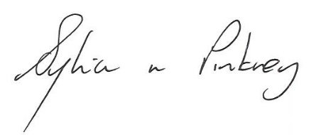

Sylvia Pinkney
Assistant Director
(Regulatory Services)

The Licensing Section
Public Protection Division
Hartlepool Borough Council
Civic Centre
Victoria Road
Hartlepool
TS24 8AY

