Community Asset Transfer Opportunity

Jutland Road Community Centre,
Hartlepool TS25 1LS

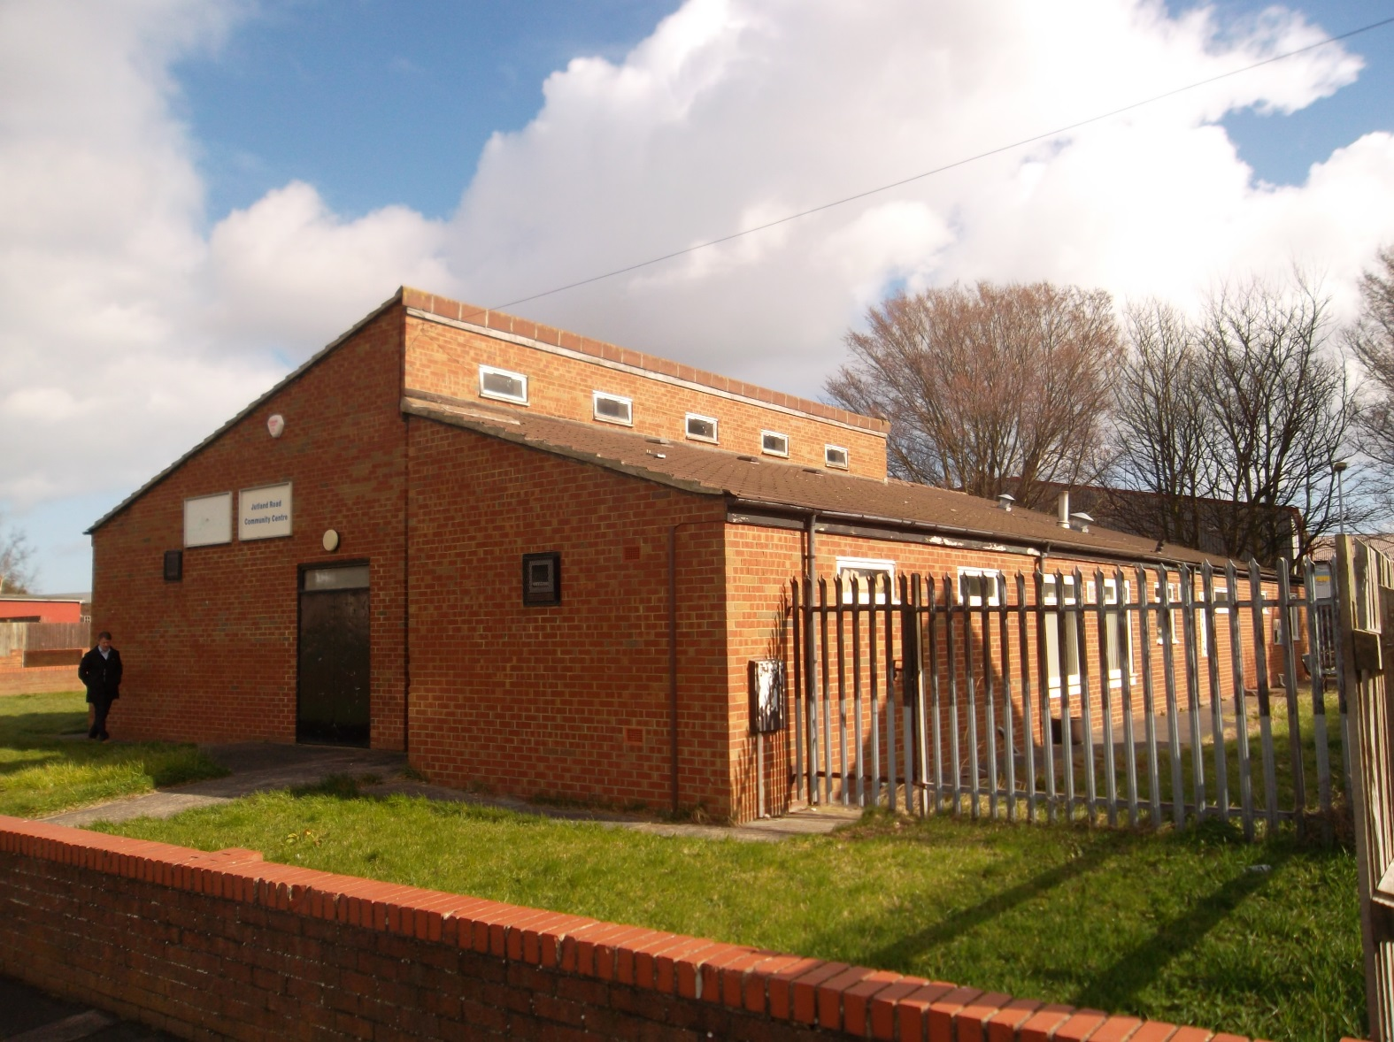

Expressions of Interest Invited

Closing Date: 12 noon on 5th August 2022

All enquiries to:
Strategic Asset Management, Civic Centre, Victoria Road,
Hartlepool, TS24 8AY

Tel: 01429 523208 Email: Estates@Hartlepool.gov.uk
Hartlepool Borough Council is seeking expressions of interest from community groups and enterprises in taking a long lease in the Jutland Road Community Centre in accordance with the broad principles of the Councils Community Asset Transfer Policy which can be viewed at Council Land and Buildings | Hartlepool Borough Council

Applicants must therefore satisfy the criteria set out in the Policy particularly that set out in Part 2 section 5 of the policy, “Which Groups are Eligible for Asset Transfer”, and provide details to evidence this.

Description

A single storey building comprising a communal hall, office space, meeting rooms, kitchen, stores and WC’s. with a gross internal area of 368.75 m². Site area amounts to 971m² and whilst there is no parking within the site, it adjoins an informal council owned car parking area.

The building has been empty for just over 3 years and has been subjected to vandalism and fire damage. It will be a condition of letting that the tenant carries out all necessary repairs to bring the property to good tenantable repair.

The former tenant has left a number of effects in the property and the tenant will be responsible for their disposal.

Location

The property is situated in the south east of the town in a residential area approximately 1.5 miles from the Town Centre. It is located at the north end of Jutland Road, adjacent to the Park View Industrial Estate, and is accessed from the south via the B1276 (Seaton Lane) or from the north via the A689 onto Queensland Road.

Use

The property operated as a Community Centre until March 2019 and would suit a continuance of this use or a similar type of use subject to planning permission if required.

Rating Assessment

The property has a rateable value of £3,100 and rates payable in 2022/23 is £1,546.90 less any Small Business Relief or any other discounts which may be available.

Services

It is understood that all major services are present within the property. It is the responsibility of prospective tenants to confirm with the relevant utility service providers their availability and suitability for their proposed use.

Energy Performance Certificate

Please see attached document

Conditions of Lease

Term

35 years

Rent

Due to the initial investment required to renovate the property the Council is offering a rent free period of 5 years. Rental offers are therefore invited from year 5 onwards.

Rent Review

Every 5 years.

Repairs

The tenant is responsible for the repair and maintenance of the property.

Insurance

The Council will continue to insure the building but the tenant will be recharged premium costs. The tenant will be responsible for contents insurance.

Assignment

Not permitted

Costs

Each party to bear their own costs

General Conditions

All expressions of interest are to be based on these Particulars

Interested parties shall be deemed to have visited and inspected the property and to be submitting their offer with full knowledge of its condition.

All necessary statutory consents are to be obtained by the lessee at their own cost prior to the commencement of development.

Viewing

Please contact Gerard Darby on 01429 523208 or email gerard.darby@hartlepool.gov.uk

Closing Date for receipt of Expressions of Interest

All expressions of interest to be made on the attached form and returned to the Managing Director in an envelope clearly marked “Expression of Interest in Jutland Road Community Centre” no later than 12 noon Friday 5th August 2022

Supporting Information

Applicants must also provide detailed information satisfying the criteria set out in Part 2 section 5 of the Councils Asset Transfer policy

Notice is hereby given that

- These particulars are set out as a general outline only for the guidance of interested parties and do not constitute, or constitute part of an offer or contract.

- All descriptions, dimensions, references to condition and necessary permissions for use and occupation and other details are given without responsibility and intending lessees should not rely on them as statements or representations of fact but must satisfy themselves by inspection or otherwise as to the correctness of each of the statements contained in these particulars.

- Hartlepool Borough Council does not make or give any representation or warranty whatsoever in relation to the property.

- None of the building services or service installations (whether these be the specific responsibility of the lessor or lessee) have been tested and are not warranted to be in safe working order.
Property Location
Location of Site

EPC
Floor Plan

Expression of Interest in Jutland Road Community Centre, Hartlepool

Name of Organisation / Group: ………………………………………………………………………………………………..

Contact Details: …………………………………………………………………………………………………………………..

Name of Contact: …………………………………………………………………………………………………………………

Address: ……………………………………………………………………………………………………………………………

Postcode: …………………………………………………………………………………………………………………………..

E-mail address: …………………………………………………………………………………………………………………..

Telephone number: ………………………………………………………………………………………………………………

Type of organisation / group (Please tick all boxes that apply)

- Partnership
- Constituted Group
- Company Limited by Guarantee
- Newly formed group for asset transfer
- Charity Voluntary Organisation
- Community Interest Company
- Consortia (If so, provide names of partner organisations) ……………………………………………………….
- Public Sector Other [please state] …………………………………………………………………………………….

Year of formation ……………….

Proposed use of property please include details of how the transfer will bring economic, social and environmental benefits to the local community (please continue on a separate sheet if necessary)

…………………………………………………………………………………………………………………………………………..
……………………………………………………………………………………………………………………………………………………………………………………………………………………………………………………………………………………………………………………………………………………………………………………………………………………………………………………………………………………………………………………………………………………………………………………………………………………………………………………………………………………………………………………………………………………………………………………………………………………………………………………………………………………………………………………………………………………………………………………………………………………………………………………………………………………………………………………………………………………………………………………………………………………………………………………………………………………………………………………………………………………………………………………………………………………………………………………………………………………………………………………………………………………………………………………………………………………………………………………………………………………………………………………………………………………………………………………………………………………………………………………………………………………………………………

RENTAL OFFER

I/We hereby offer the sum of £…………………per annum payable on the 5th anniversary of the lease and subject

to review every 5 years thereafter.

